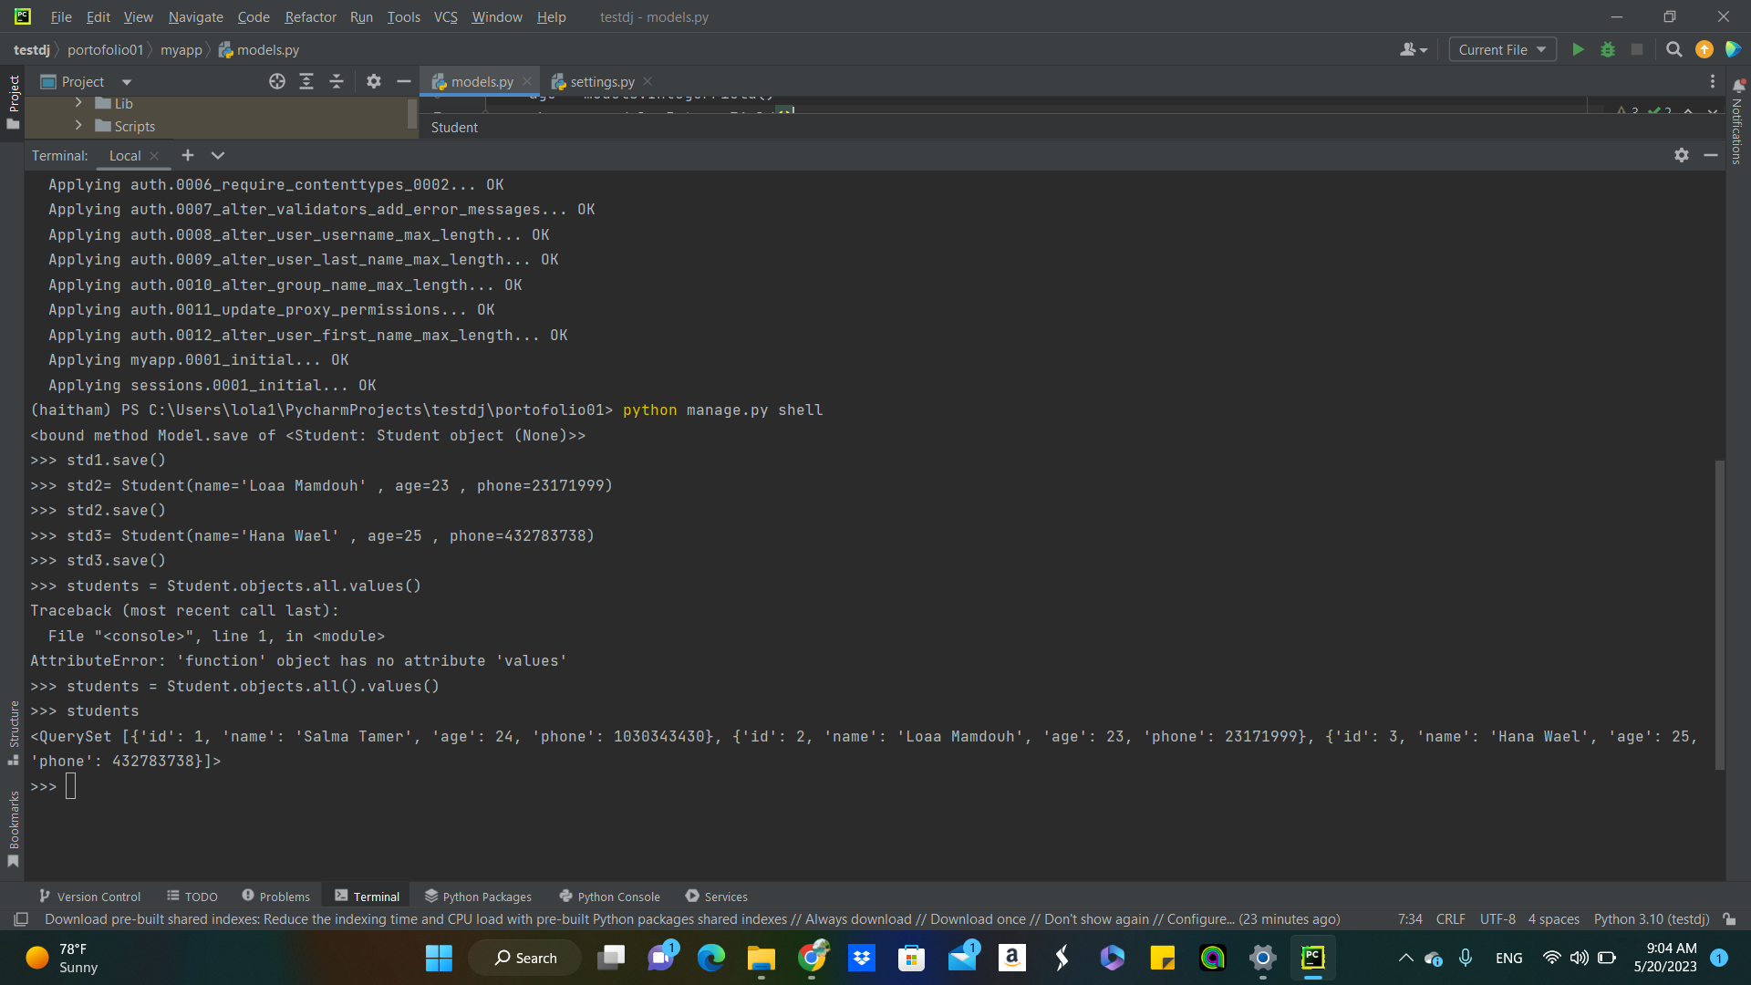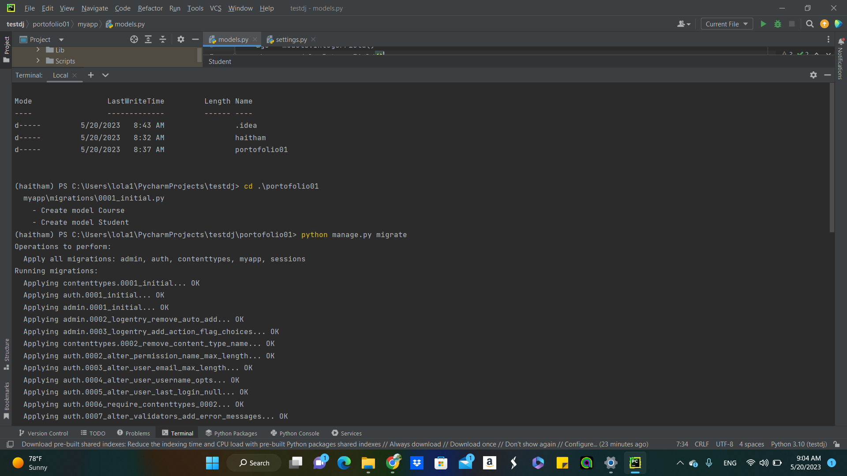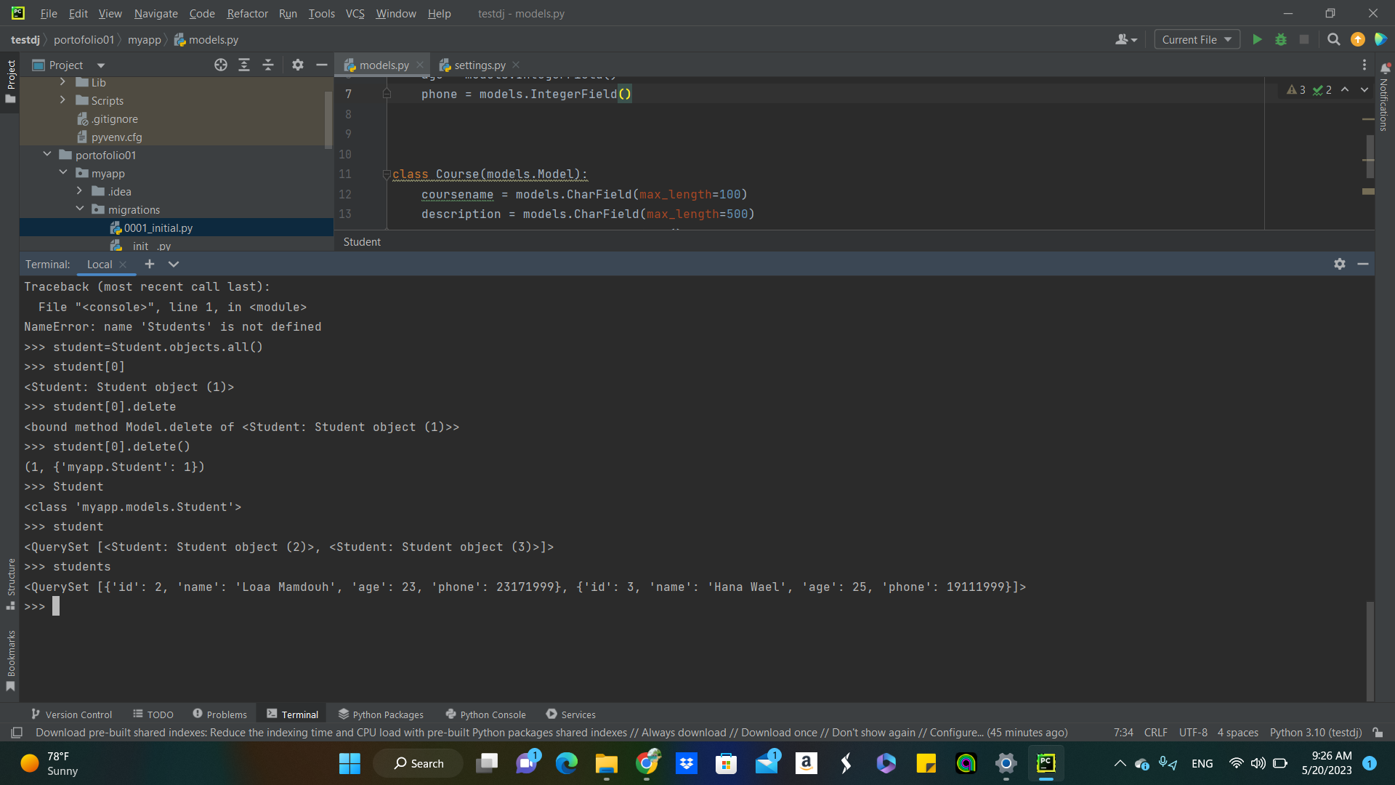

1. I uploaded the students data by entering each student by itself
2. Made sure that the students data can be seen whether as objects or full details
3. Did the migration process to create the database and save data
4. Updated student(3) number
5. Deleted first student